How to Cook Beer Can Turkeyhe classic beer can chicken this recipe will give your turkey a moist and juicy you s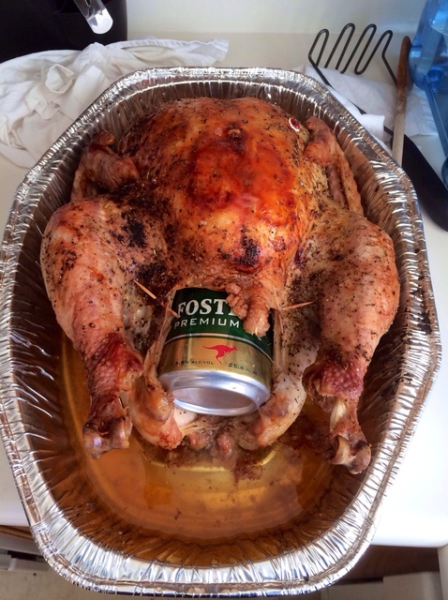ee

**INGREDIENTS**

**1**

Preheat oven to 350° F Cook time is 15-20 minutes per pound.

**2**

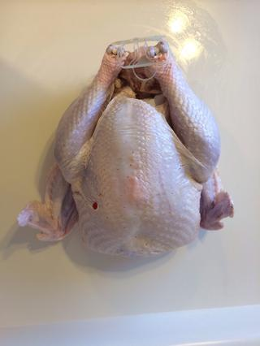

Rinse turkey

**3**

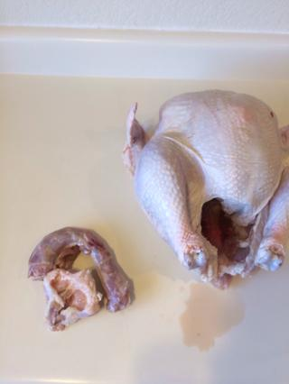

Remove giblets.

**4**

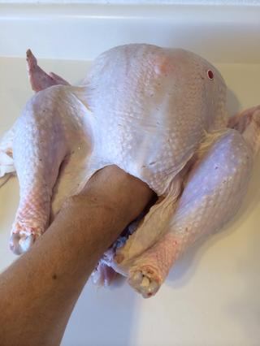

Remove excess fat from cavity.

**5**

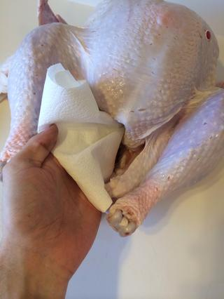

Pat inside dry with paper towel.

*Comment*

**6**

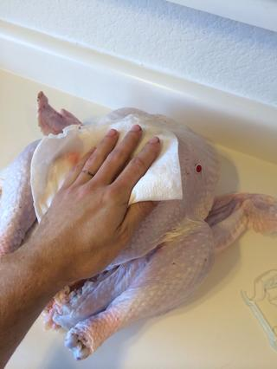

Pat outside of turkey dry.

**7**

Grab seasonings.

**8**

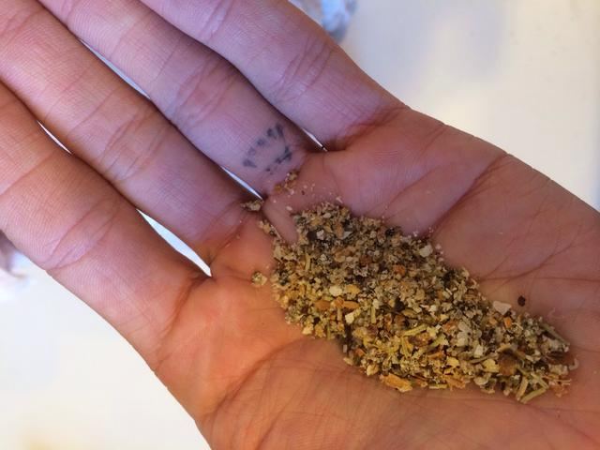

Mix seasonings together.

**9**

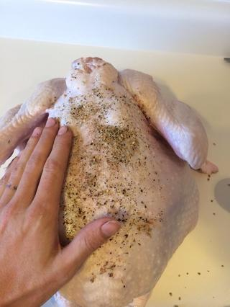

Rub on seasonings to turkey inner and outer.

*Comment*

**10**

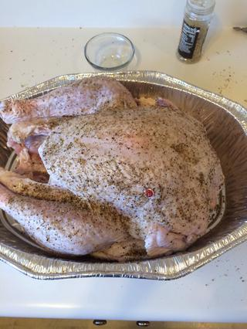

Put in roaster pan to get the turkey completely covered.

*Comment*

**11**

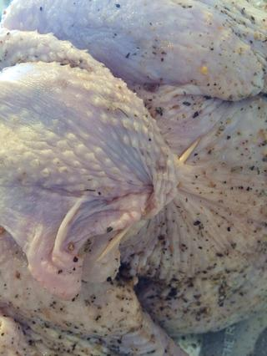

Fold the neck skin over to close up the hole in the neck so the steam doesn't escape and pin it with toothpicks.

*Comment*

**12**

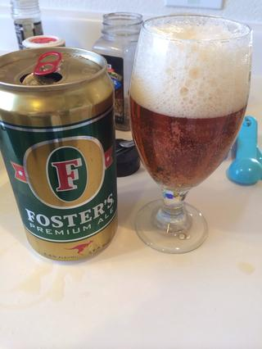

Pour out half the beer.

*Comment*

**13**

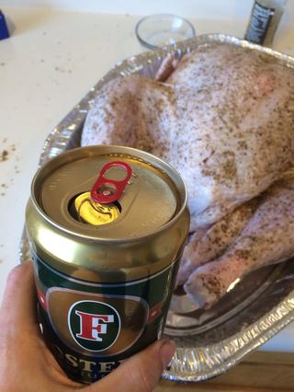

Insert beer can tab toward the back of the opening the neck side. MAKE SURE THE TAB OPENING IS POINTING UPWARDS SO THE BEER DOESN'T POUR OUT.

*Comment*

**14**

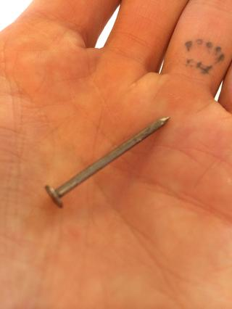

Use a household nail or skewer or something sharp and poke the can in two spots on opposite ends.

*Comment*

**15**

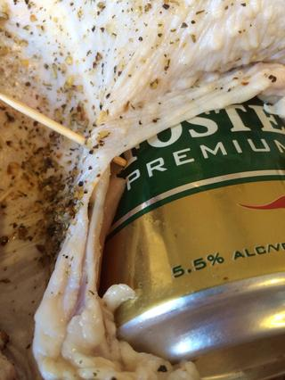

Stretch the bottom skin and insert tooth pick piercing the skin and the hole in the can.

*Comment*

**16**

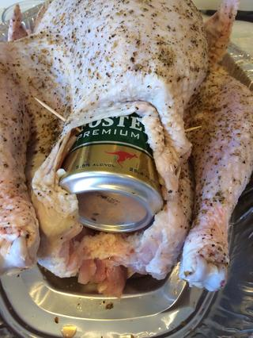

This is to prevent the can from turning and tipping over spilling your beer. Party foul.

*Comment*

**17**

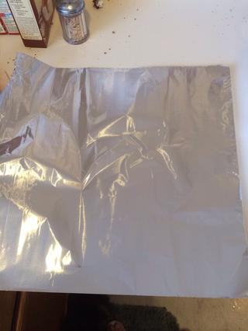

Get aluminum foil large enough to go across the turkey horizontally to tent the bird.

*Comment*

**18**

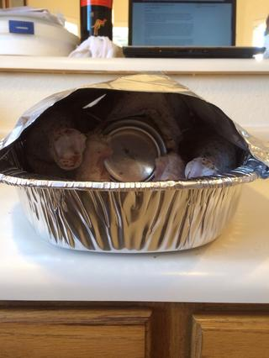

Leaving the ends open is okay.

*Comment*

**19**

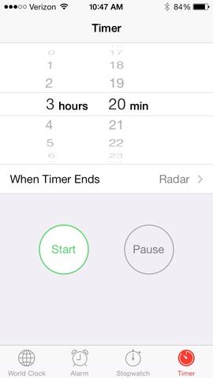

Put in oven for a little over half the time. Mine is a 17 lb. bird.

*Comment*

**20**

Drink the beer you poured out in step 12.

**21**

Remove the foil for the second half of the cooking time, this produces a fantastic dark brown crispy skin.

*Comment*

**22**

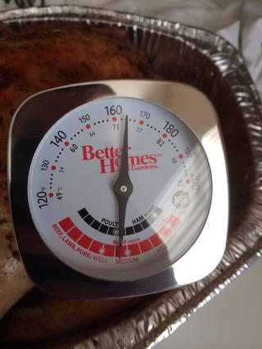

When the temperature reaches 160-170° F remove turkey, let rest for 15 minutes minimum with the beer can in place before carving.

*Comment*

**23**

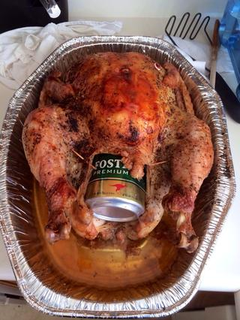

And finished product!

*Comment*

**24**

Note: The temperature of the bird will rise a few degrees as it rests so don't worry. If you over-cook to the 170+°F range the moisture drops. No one likes a dry turkey!

